Sprint Retrospective – Sellers Crum

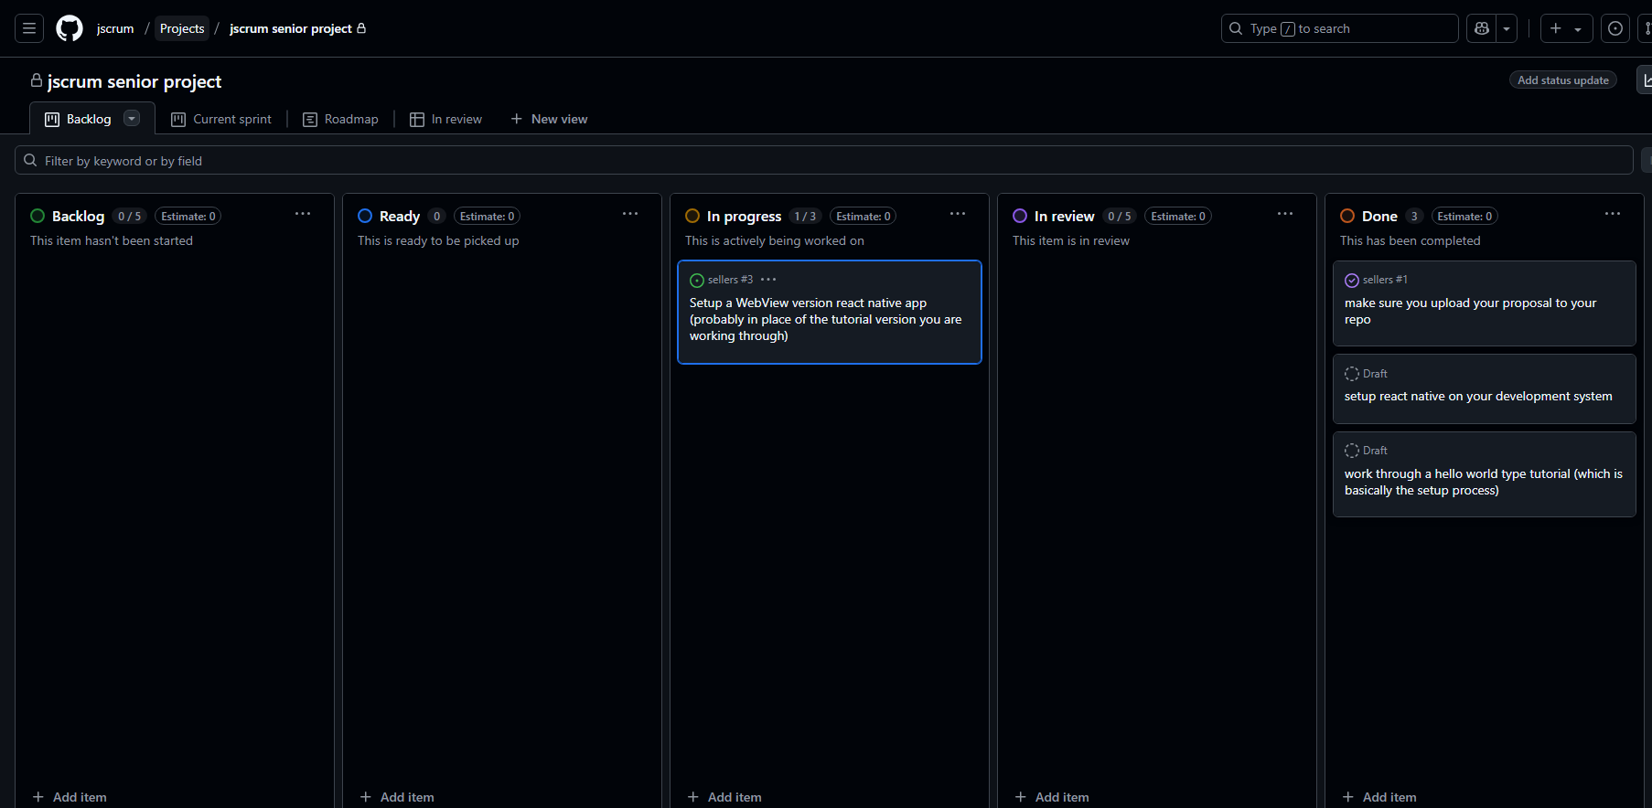

Project Title
MyBikeTrafficApp

Sprint Number
Sprint 4

Sprint Duration
March 5 - 19

Date of Retrospective
March 20

Sprint Goals
Create WebMv version of app

Accomplishments
The goal was attempted but not accomplished

Challenges
Errors. Not enough time to work through in the semester.

Next Steps
Try to transfer some data from the website

